TECHNICAL REPORT 1

PROCESS OF MAKING WORDPRESS WEBSITE WITH R SHINY GRAPHS

To make this website, we installed “WAMP SERVER”. This act as a helping tool to create a website in wordpress.

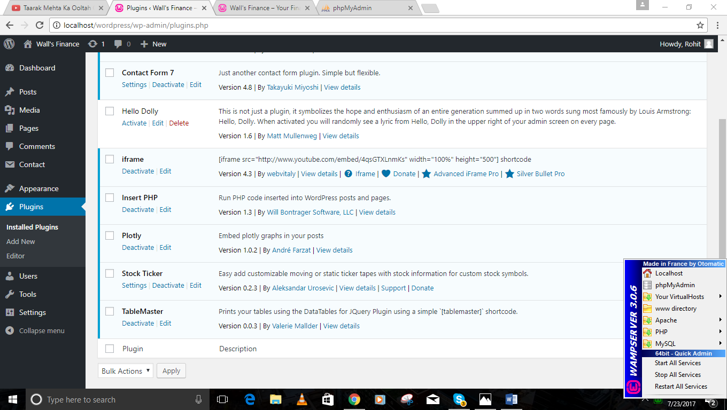

This is the dashboard of wordpress in which various options are available for making website. We use to customized our website through this.

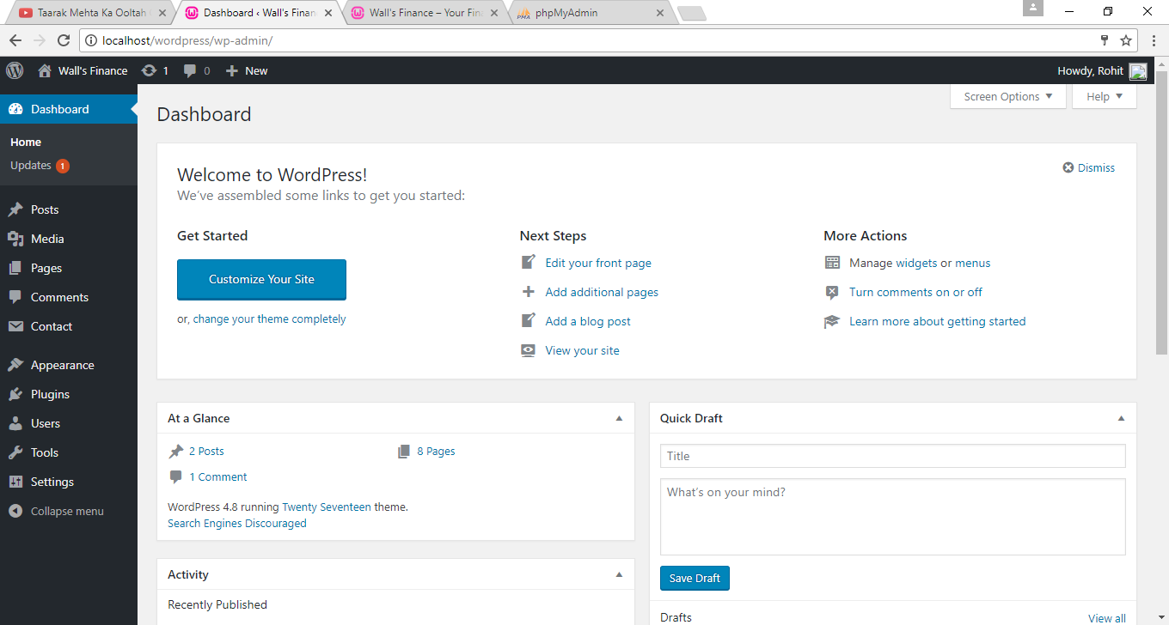

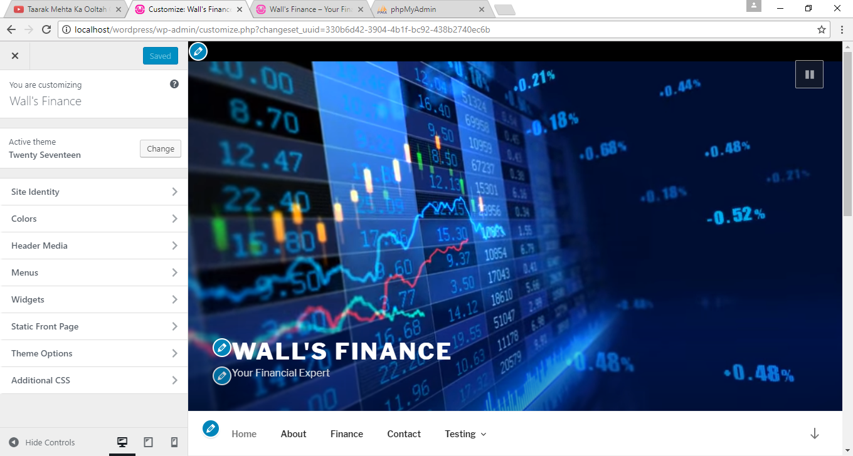

In wordpress, we need to install Plugins. We have used this plugins for our website.

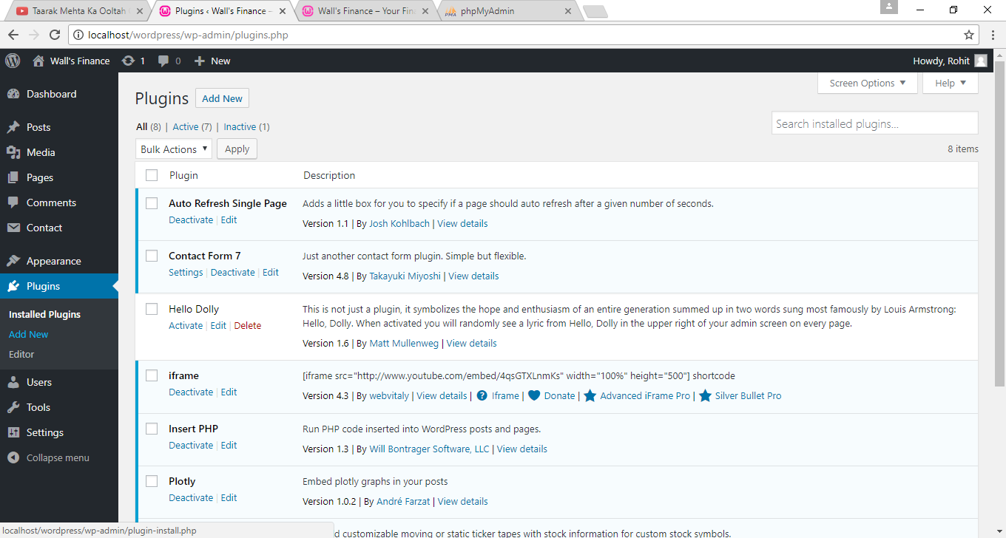

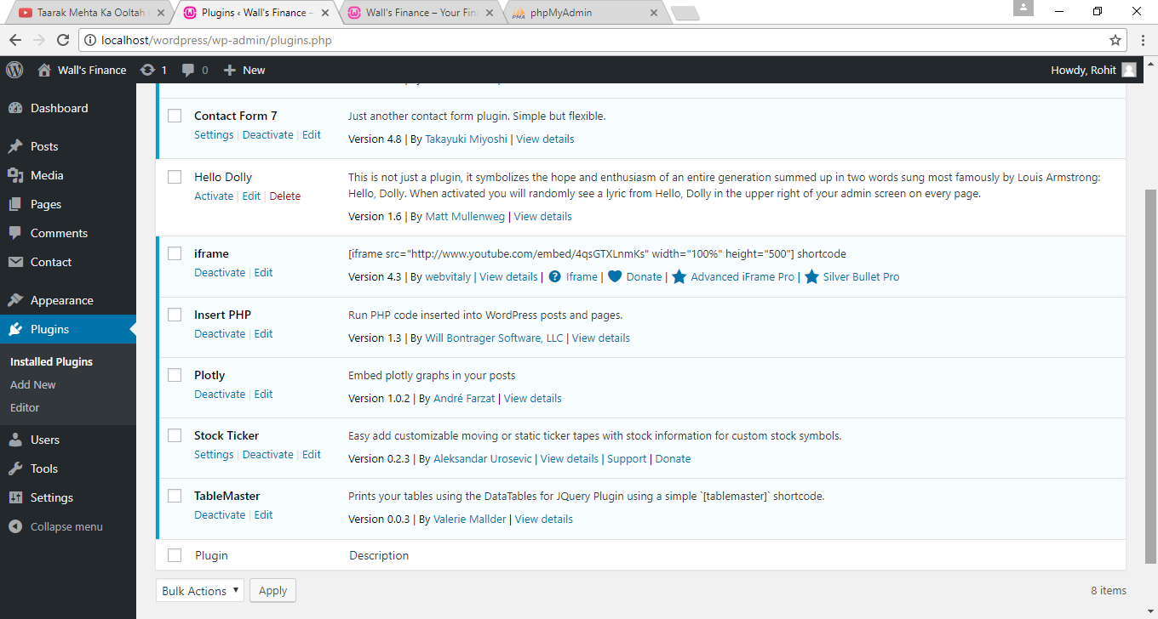

Wordpress offer very simple way to add web pages. We have made these pages.

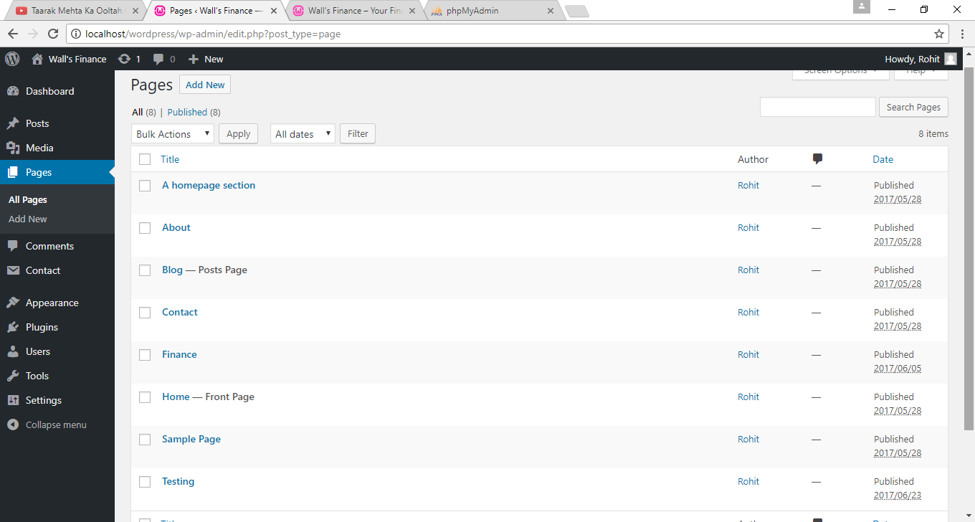

This is our finanace page in which we put our coding for put and calls dynamic tables withAPIi. There is also coding of our Rshiny graphs.

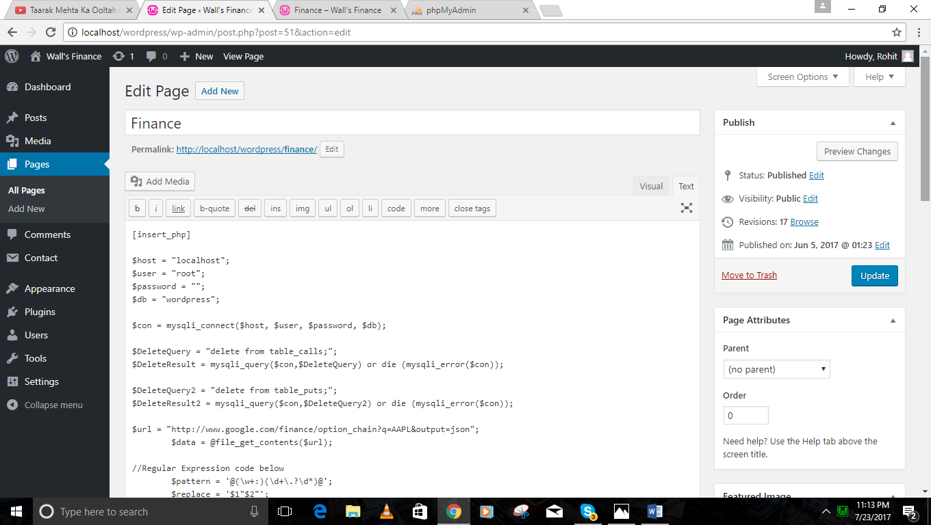

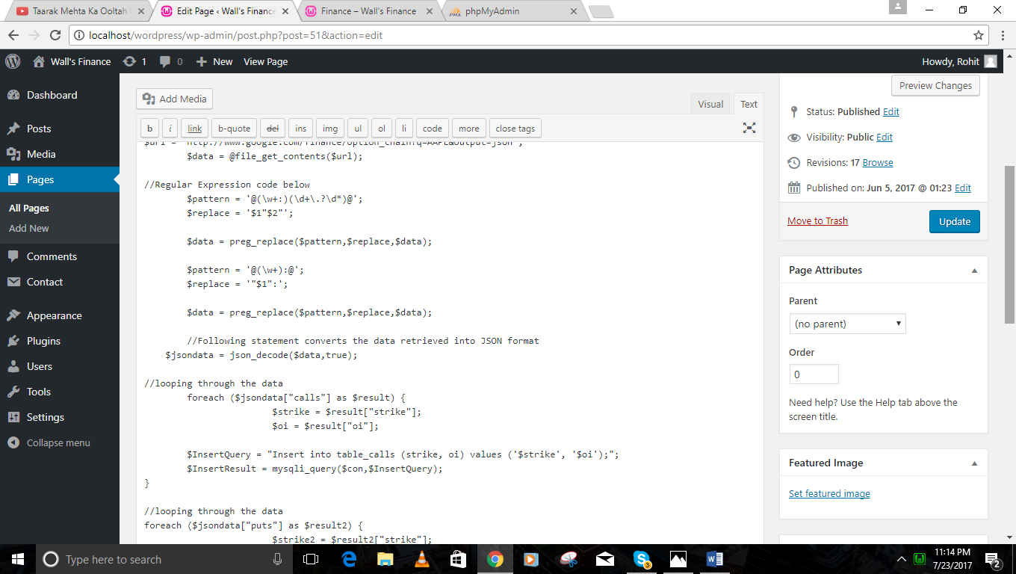

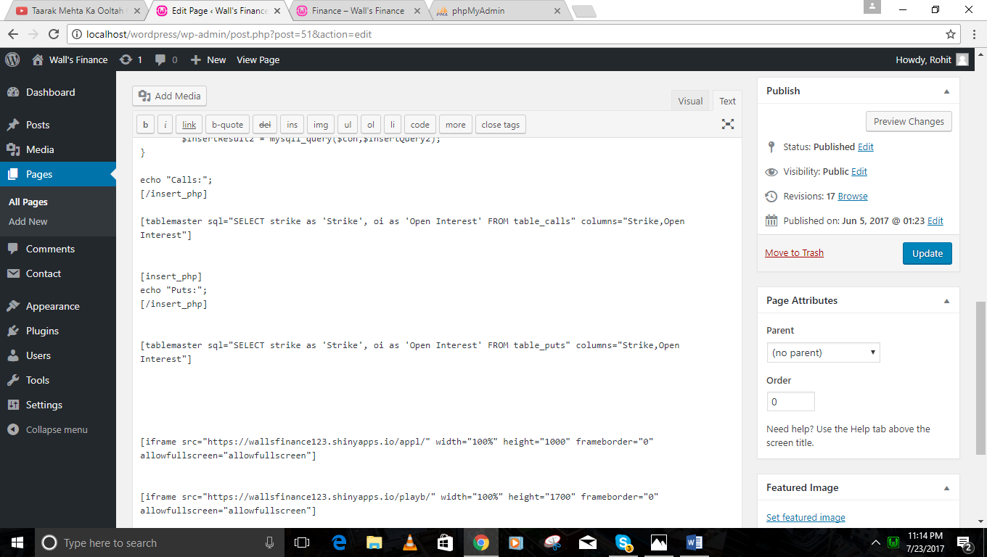

This is our another page in which we have added coding of graphs made by other group.

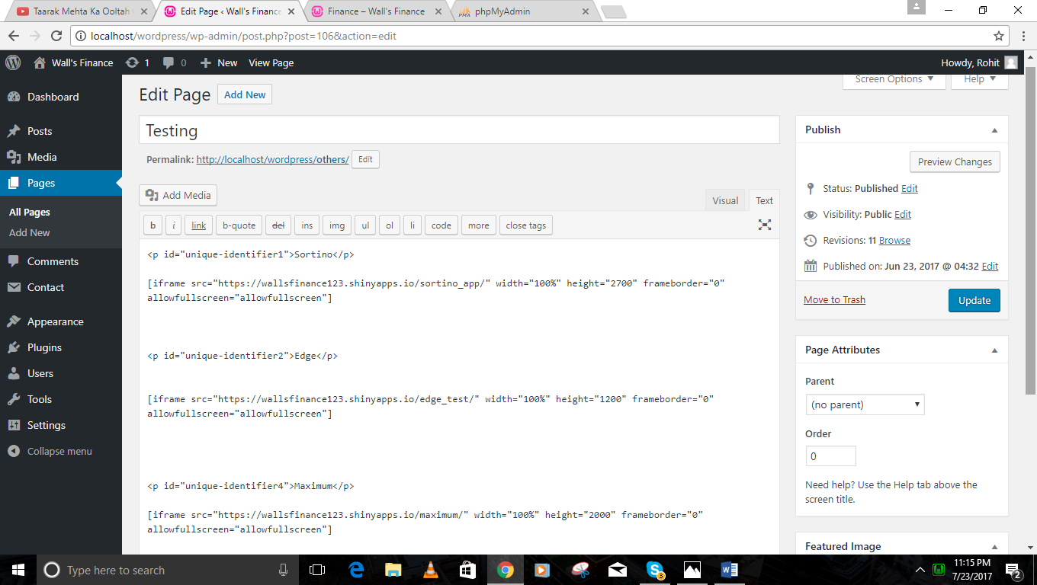

In the API which we have used for our tables, there were some errors. We have validated that API through JSON validator.

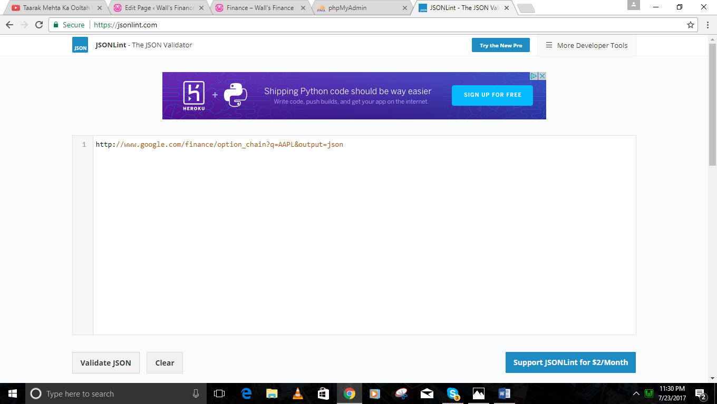

This shows the errors in API.

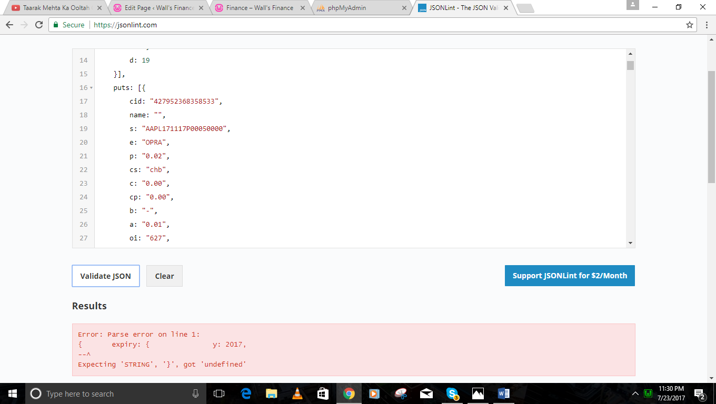

These are the tables which we have created in php myadmin. We have created table calls and puts.

